## VISVESVARAYA TECHNOLOGICAL UNIVERSITY

### BELGAUM-590 014



**2021-2022**

**A Project Report on**

## “ECO-FERTILIZATION”

Submitted in partial fulfillment for the award of degree of

##### Bachelor of Engineering in

**Computer Science & Engineering**

by

Name: **Gaurav Sharma**

USN: **1AT18CS128**

Under the Guidance of

#### Dr. Manash Sarkar

Associate Professor, Dept. of CSE, AIT



DEPARTMENT OF COMPUTER SCIENCE AND ENGINEERING

#### ATRIA INSTITUTE OF TECHNOLOGY

BANGALORE- 560024

2021-22

#### ATRIA INSTITUTE OF TECHNOLOGY

**Department of Compute Science & Engineering BANGALORE-560024**



#### CERTIFICATE

Certified that the project work entitled **“Eco-Fertilization”**, carried out by **Gaurav Sharma (1AT18CS128),** a bonafide student of **Atria Institute of Technology,** in partial fulfilment for the award of Bachelor of Engineering in **Computer Science & Engineering of Visvesvaraya Technological University, Belgaum** during the academic year 2021-2022. It is certified that all corrections/suggestions indicated for Internal Assessment have been incorporated in the Report deposited in the departmental library. The project report has been approved as it satisfies requirement in respect of project work prescribed for the said degree.

|  |  |  |
| --- | --- | --- |
| **Signature of Guide** | **Signature of HOD** | **Signature of Principal** |
| **Dr. Manash Sarkar** | **Dr. Aishwarya P** | **Dr. K V Narayana Swamy** |

##### External Viva

**Name of the Examiners Signature with date**

1.

2.

# 

# DECLARATION

**Gaurav Sharma**, student of VIII semester B.E in Computer Science & Engineering at Atria Institute of Technology, hereby declare that the project work entitled “**Eco-Fertilization** using Machine Learning” has been carried out under the supervision of Prof. Manash Sarkar, Associate Professor, Dept. of CS&E, Atria Institute of Technology and submitted in partial fulfilment of the course requirements for the award of degree in B.E in Computer Science & Engineering of Visvesvaraya Technological University, Belagavi during the year 2021-2022. We further declare that the report has not been submitted to any other University for the award of any other degree.

##### Place: Bangalore Gaurav Sharma

**Date: 1AT18CS128**

# ABSTRACT

Fertilizer use is typically under the limited control of farmers. For the farmers to achieve higher yields and reduce fertilizer loss, competent guidance is required for the best use of these fertilizers. Additionally, there is a connection between rainfall volume and nutrient loss for various fertilizer applications after each rainfall event. Rainfall that is moderate and falls at the right moment can help nutrients penetrate the soil's rooting zone and dissolve dry fertilizer. However, too much rain can increase the possibility of runoff and the pace at which nutrients like nitrogen (N) which is quintessential, phosphorus (P), and potassium (K) which are crucial, manganese (Mn), and boron (B) that are present in the soil. This research presents nutrient recommendations using an updated iteration of the random forest algorithm which is based on time-series data to forecast the required quantity of nutrients for various crops by examining rainfall patterns and crop fertility. The method suggested in this study, comes in handy for improving soil fertility by providing nutrients recommendations for optimum conditions for crop growth and reducing leaching and runoff potential.

# ACKNOWLEDGEMENT

We express gratitude to our institution and management for providing us with good infrastructure, laboratory, facilities and inspiring staff, and whose gratitude was of immense help in completion of this project successfully.

We express our sincere gratitude to **Dr. K.V. NARAYANA SWAMY,** Principal, Atria Institute of Technology, for providing us the required environment and for his valuable suggestion.

Our sincere thanks to **Dr. AISHWARYA P,** Head of the Dept. Computer Science and Engineering, Atria Institute of Technology, for her valuable support and for rendering us resources for this project work.

We express our gratitude to **Dr. Manash Sarkar,** Associate Professor, Dept. of Computer Science and Engineering, Atria Institute of Technology, who guided us with valuable suggestions in completing this project at every stage.

Last but not the least, the project would not have been a success without the support of our **parents** and **friends**. Our sincere thanks should be rendered to everyone who helped us in all possible ways.

# TABLE OF CONTENTS

DECLARATION i

ABSTRACT ii

ACKNOWLEDGEMENT iii

LIST OF FIGURES …vi

LIST OF TABLES. vii

CHAPTER I INTRODUCTION [1-3]

* 1. Machine Learning… 2
  2. [Purpose 2-3]
  3. Objectives . ….3

CHAPTER II LITERATURE SURVEY ..[4-5]

CHAPTER III SYSTEM REQUIREMENTS SPECIFICATION 6

* 1. Hardware Requirements 6
  2. Software Requirements 6

CHAPTER IV SYSTEM DESIGN ..[7-11]

* 1. Architectural Design …[7-8]
  2. Data Flow Diagram …[8-9]
  3. Class Diagram 10
  4. Sequence Diagram 11

CHAPTER V IMPLEMENTATION [12-23]

* 1. Random Forest Regression…………………………………………………[12-13]
  2. Cross-Validation 14
  3. Dataset 15
  4. Dataset Preparation 16
  5. Input Features 17
  6. Output Features 17
  7. Python [17-18]

CHAPTER VI SOFTWARE DESCRIPTION [42-53]

* 1. VS CODE
  2. FLASK
  3. GIT
  4. JUPYTER NOTEBOOK
  5. PYTHON

CHAPTER VII RESULTS [54-56]

CHAPTER VIII FUTURE WORKS 57

* 1. Future scope 57

CHAPTER IX CONCLUSION [58-59]

CHAPTER X PAPER PUBLICATION DETAILS 60

REFERENCES [61-62]

# LIST OF FIGURES

|  |  |  |
| --- | --- | --- |
| **FIGURE NO.** | **DESCRIPTION** | **PAGE NO.** |
| 1 | On-Ground Analysis | 01 |
| 1.1 | Machine Learning Classification | 03 |
| 1.3 | Soil Leaching | 05 |
| 4.1 | Block Diagram | 07 |
| 4.2 | Data flow Diagram | 09 |
| 4.3 | Class Diagram | 10 |
| 4.4 | Sequence Diagram | 11 |
| 5.1 | Random Forest Regression | 13 |
| 5.2 | K-Cross Fold Validation | 14 |
| 5.3 | Actual Dataset | 15 |
| 5.4 | Customized Dataset | 16 |
| 5.7 | Python logo | 18 |
| 5.8 | Flask logo | 18 |
| 5.9 | HTML logo | 20 |
| 5.10 | CSS logo | 21 |
| 5.12 | JavaScript logo | 23 |
| 6.1 | VS Code logo | 24 |
| 6.2 | Git logo | 25 |
| 6.3 | Jupyter Notebook logo | 25 |
| 7.1 | Homepage of Eco-Fertilization | 26 |
| 7.2 | Input Form | 27 |
| 7.3 | Details filled using the drop-down menu | 27 |
| 7.4 | Applying Algorithm to inputted details | 28 |
| 7.5 | Output with seven days of weather forecasts & alerts/messages | 28 |

# LIST OF TABLES

|  |  |  |
| --- | --- | --- |
| **TABLE NO.** | **PARTICULARS** | **PAGE NO.** |
| 4.1 | Block Diagram Functionalities | 08 |
| 5.1 | Random Forest Regression Algorithm | 13 |

# INTRODUCTION

**CHAPTER I**

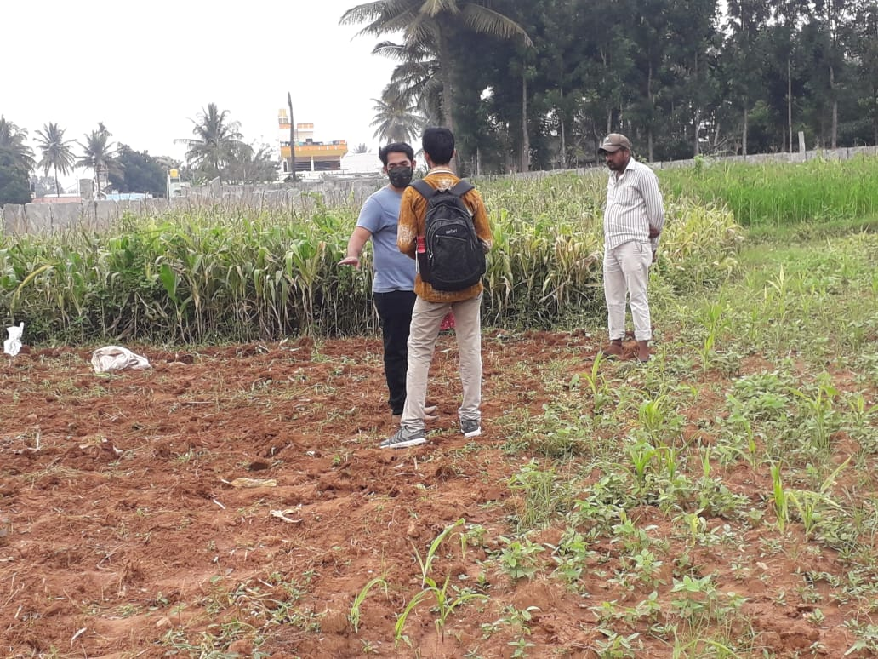Agriculture plays a very important role in national economic growth. Agriculture contributes 17-18% to India's GDP and ranks second worldwide in farm outputs. Plants need fertilizers and fertilizers replace the nutrients which crops take from the top layer of the soil. The absence of fertilizers can cause a drastic reduction in the volume of crop output. But fertilization requires precise action. Rainfall patterns and the amount of nutrients needed for a certain crop must be considered when using fertilizers. Machine learning is the current technology that can solve this problem by using available data for crop fertility and rainfall. Farmers can greatly benefit from the support of robust information about crops. The proposed model also uses a machine learning algorithm (random forest algorithm with k-fold cross-validation technique) and takes two inputs from the user that are crop and location. After applying the algorithm, the model predicts the amount of nutrients required along with the best time to use fertilizers. The website is built using Flask Python (web framework) to provide access on all platforms and can be shared among users.

Fig. 1: On-Ground Analysis

## Machine Learning

The study of machine learning (ML) focuses on comprehending and developing "learning" techniques, that employ data to enhance performance on a variety of tasks. It is considered a component of artificial intelligence. Without the need for explicit programming, machine learning algorithms create a model from training data and use it to generate predictions or judgments. When it is difficult or impossible to develop conventional algorithms, machine learning algorithms are utilised in a range of fields, including medicine, email filtering, speech recognition, and computer vision. On the other hand, machine learning is not solely statistical learning. A subset of machine learning is computational statistics, which focuses on computing-based prediction. Mathematical optimization research benefits machine learning by providing tools, theory, and application fields.

**What makes machine learning so crucial?**

Machine learning is significant because it aids in the development of new goods and provides businesses with a picture of trends in consumer behaviour and operational business patterns. Machine learning is a key component of the operations of many of today's top corporations, including Facebook, Google, and Uber. For many businesses, machine learning has emerged as a key competitive differentiation.

**What are the various kinds of machine learning?**

How an algorithm learns to improve its prediction accuracy is a common way to classify traditional machine learning. There are four fundamental strategies: reinforcement learning, semi-supervised learning, unsupervised learning, and supervised learning. The kind of data that data scientists wish to predict determines the kind of algorithm they use. Different kinds of machine learning algorithms are:

* *Supervised learning:* In this type of machine learning, data scientists provide labelled training data to algorithms and specify which variables they want the algorithm to look for correlations between. The algorithm's input and output are both specified.
* *Unsupervised learning:* Algorithms that train on unlabelled data are used in this type of machine learning. The algorithm scans data sets for any meaningful connections. The data used to train algorithms, as well as the predictions or recommendations they produce, are predetermined.
* *Semi-supervised learning:* The above two forms of machine learning are combined in this method. An algorithm may be fed mostly labelled training data by data scientists, but the algorithm is allowed to analyse the data on its own and come to its own conclusions about the data set.
* *Reinforcement learning:* Reinforcement learning is frequently used by data scientists to train a machine to finish a multi-step process with well-defined rules. An algorithm is programmed by data scientists to fulfil a goal, and they provide it with positive or negative feedback as it determines how to do so. However, the algorithm typically chooses the course of action on its own.

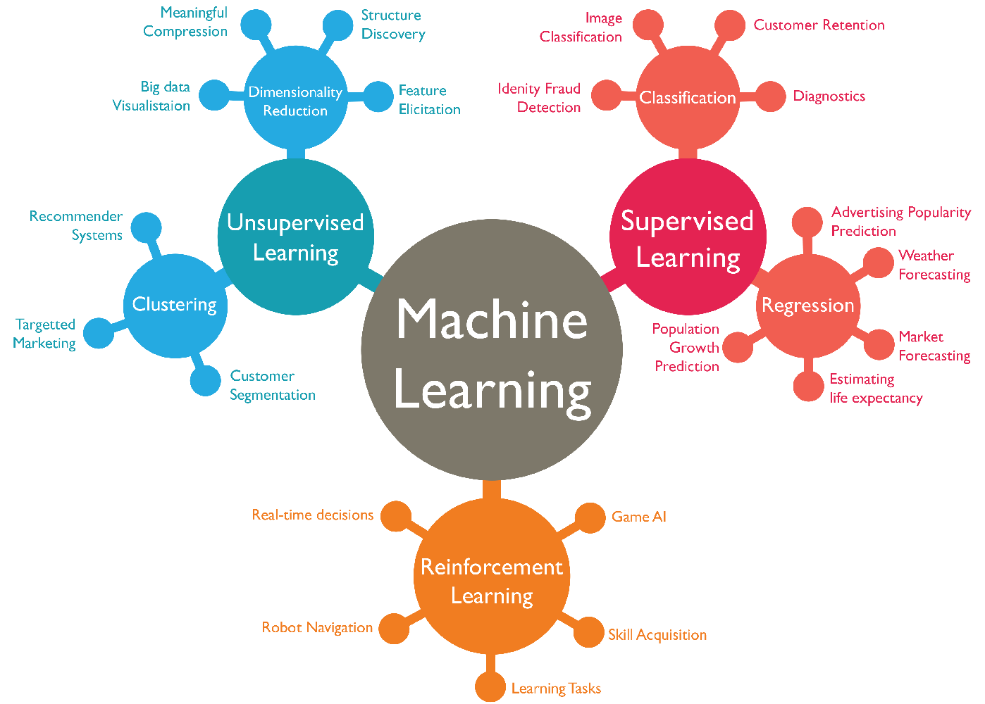

Fig 1.1: Machine Learning Classification

## Plant Root Loss

Farmers face a number of challenges every year like, heavy rainfall or unpredictable weather, including high interest rates, an overreliance on traditional crops, and a lack of water. Crops may be submerged in water as a result of flooding, which could cause catastrophic losses. As soon as a plant is submerged, its foliage starts to deteriorate because its leaves are unable to exchange gases with the air above (mainly oxygen & carbon dioxide). Producers face flooding or continuously flooded soil more frequently, which hinders roots' ability to absorb nutrients. If the soil is completely soaked for an extended period of time, root loss may result. Because they can't exchange gases, root cells in waterlogged soils risk dying.

Depending on how long the soil is entirely soaked, different amounts of root loss may occur. Plant mortality and complete crop failure would ensue from total root loss. Lower plant performance and crop output would result from partial root loss. Conditions that are too moist might have other detrimental effects on crop productivity. Unusually excessive rainfall can wash away nutrients from the soil, particularly nitrogen. Granular fertilizer that has been put to the soil as nitrogen is particularly susceptible to leaching. If this happens, farmers would either have to pay more money to reapply fertilizer or see a decrease in crop yield due to nitrogen shortage.

## Soil Leaching

Leaching is the downward transport of pollutants via porous soils, such as water-soluble pesticides or fertilizers. The majority of pesticides, notably clay, adhere to soil particles, become stationary, and do not drain. However, the multiple degradation mechanisms and leaching to groundwater can be seen as competitors in the fate of mobile pesticides. Groundwater does not continuously dilute the pollutants that enter it, in contrast to surface water. It could take many years to remove a contaminated plume from groundwater. Chemical deterioration is slowed by the soil's depth, the freezing temperatures, the limited microbial activity, the lack of sunlight, and the low oxygen levels. As a result, once pesticides enter an aquifer, there is little to no degradation, if any at all. This leads to water pollution.

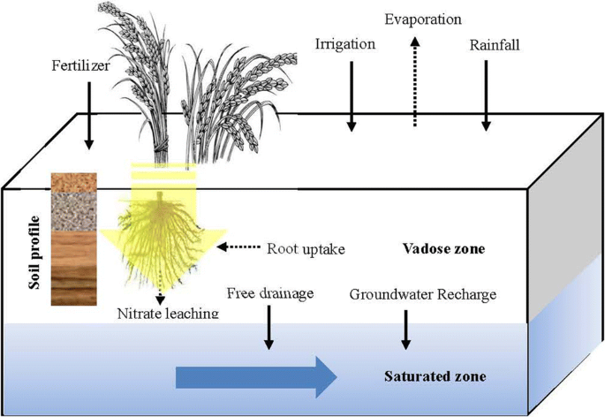

Fig 1.3: Soil Leaching

**Soil Features that Influence Leaching:**

* *Organic Matter:* The amount of organic matter in a soil is thought to be the single factor that has the greatest impact on how microorganisms break down pesticides. Pesticides are less likely to leach into groundwater because organic matter in the soil improves the surface area available for adsorption, boosts the soil's capacity to retain water and break down pesticides, and nourishes microorganisms. Crop leftovers can be added to the soil, manure can be added, and cover crops can be grown to increase the organic matter in the soil.
* *Soil Texture:* The amounts of sand, silt, and clay in the soil have an impact on how water moves through it. Large pores and high permeability characterize coarse-textured soils with more sand particles, which allow water to pass through quickly. Groundwater is more likely to become contaminated by pesticides delivered by water via soil with a coarse texture. Soils with a clay texture have less permeability. More water is retained and more chemicals are absorbed from the water by soil with high clay content. This lessens the likelihood of groundwater pollution, increases the likelihood of chemical breakdown and binding to soil particles, and slows the downward migration of the pollutants.
* *Soil Structure:* Water can travel through the soil quickly because to loosely packed soil particles. Tightly compacted soil acts as a dam, holding water back and preventing its free flow. Openings and channels can be made for water flow in a number of different ways. For instance, animals and earthworms generate openings for water to flow through when they dig burrows. In soil and rock, freezing and thawing causes fissures or splits that dislodge compacted particles. When plant roots decay and die, they pierce the soil and make great water routes. Even through some clay soils, these apertures and channels might allow for a somewhat quick water flow.
* *Soil Water Content:* Rain or irrigation can recharge the groundwater and perhaps cause pesticides to seep into the aquifer, depending on how much water is already present in the soil. Once soil moisture content is getting close to or near saturation, soluble substances are much more likely to enter groundwater. When it rains and there is snowmelt in the spring, saturation is normal. Contrarily, when soils are dry, the additional water simply fills soil pores close to the soil surface, decreasing the likelihood that it will contact the groundwater supply.

## Purpose

The main motive behind Eco-Fertilization is to reduce farmers losses by providing useful insights about the amount and use of fertilizers, and to reduce water pollution by slowing down the process of leaching. It serves as a link between farmers and modern technology and enables them to increase yields while using less inputs. The system is designed as a website to provide platform-independent functionality, so that the user can access it from any device. The user interface has been kept simple with more emphasis on functionality and can be used by any naive user. It takes inputs such as crop, state and city using the drop-down menus provided in the website and applies machine learning algorithms to estimate the correct amount of nitrogen, potassium and phosphorus content required. This system provides a good accuracy in its decision about the nutrients required for the crop.

## Objectives

Crop production is essential to the global food and biofuel economies, and ML is significantly enhancing farmers' contributions on both fronts. To enhance crop productivity and yield, herbicides, insecticides, and fungicides must all be applied at the right time. Even if crop spraying is possible later in the season as soil moisture decreases, crop yields will almost certainly be harmed. Every year, farmers make hundreds of intricate and connected decisions that affect their risk, sustainability, and financial results.

The goal of employing machine learning in our project is to provide relevant insight for nutrient requirement for crops by taking short-term weather forecasts (specifically for seven days) into account, as well as to prevent water pollution by slowing down the leaching process.

# LITERATURE SURVEY

**CHAPTER II**

A comprehensive study of the available literature presents a catalog of previous studies to address this issue. The authors show in [1] that predicting fertilizer usage can assist farmers to attain a proper yield with little waste by preventing toxicity and deficiency in plants to some extent. Paper [2] makes use of fuzzy logic systems that enable the reduction of fertilizer usage which results in an increase in crop productivity. Additionally, [10] shows that the enhanced efficiency of fertilizers is not sufficient for complications that can be caused by compaction. These issues can be prevented by improving the fertilizer recommendation which requires the establishment of a quantifiable relation under N and P for fertilizer usage, in terms of agricultural yield, nitrogen need, and nitrate remnant level which is shown in [11] and paper [4] seconds this by providing a comprehensive measure to estimate the weightage of nutrient requirements and also the role of the chemical properties of soil.

It is a difficult task to predict crop yield due to stochastic rainfall patterns and also temperature variation. So, we can apply different data mining techniques as propounded in [3] for crop yield prediction. Laura J.T. Hess et al. in [5] state that nitrogen leaching is prone in areas that have no-till management and this may cause crop loss. In [7] the authors suggest a novel metric for ‘soil health and quality’ including refinement of soil’s health.

The objective of the paper [8] is to examine the characteristic changes in the creation and elements of soil populaces and capabilities because of the collaboration between long haul treatment and precipitation variances, to decide if preparation history affects the water-obstruction of soil microorganisms. Also, Paper [13] predicts agricultural yield as a function of rainfall. This is accomplished by giving a general summary of how production is affected by rainfall and how much a given crop can yield given the amount of rainfall received. Because it examines all regression procedures, the suggested method of evaluation is superior to other existing methods of evaluation.

Potnuru Sai Nishant et al. in paper [6] predict the yield of practically all types of crops in India. This script makes innovative use of straightforward criteria such as state, district and area, allowing the user to forecast crop yields in any year. Paper [12] suggests the use of Transfer Learning techniques to create a pre-trained model for detecting patterns in the dataset, which we then used to predict crop yields. In [14], supervised algorithms that boost crop yields, reduce human labor, time, and energy exerted on various agricultural tasks, and plant suggestions based on particular soil parameters are used to produce a complete way to predict crop sustainability. The study [16] demonstrated the capabilities of a machine learning model that can interpret and evaluate results, can be utilized to create the most useful information in long-term fertilizer studies, and that these methods can be employed in other long-term experiments. Paper [17] develops an interesting decision-based system on climatic, crop, and insecticide/pesticide data. This is done

Senthil Kumar Swami Durai et al. in [18] propose an integrated solution to Pre-Cultivation activities. The goal of this study is to assist a small farm in becoming more efficient and achieving a high production at a low cost. It also aids in the estimation of total growth expenses. It will assist one in planning forward. Pre-cultivation activities lead to an integrated solution in agriculture. M.S. Suchithra and Maya L. Pai propose solutions to soil nutrient classification problems utilizing the rapid learning classification technique called an Extreme Learning Machine (ELM) with various activation functions in [19].

Crop diseases are one of the primary causes that impact the overall yield. Paper [15] conducts this study using an IoT system in the Kashmir Valley, it proposes an apple disease prediction model using data analysis and machine learning. The challenges of incorporating new technology into traditional agricultural practices are discussed in this paper.

# CHAPTER III

# SYSTEM REQUIREMENTS SPECIFICATION

## Hardware Requirements

* Processor: Intel(R) Core(TM) i3-4005U CPU @ 1.70GHz
* RAM: 4.00 GB
* System type: 64-bit operating system, x64-based processor
* Network Interface Card
* Keyboard
* Mouse

## Software Requirements

* Operating System (any)
* Google Chrome (web browser)
* Visual Studio Code
* Jupyter Notebook

**CHAPTER** **IV**

# SYSTEM DESIGN

System design is the process of defining the architecture, components, modules, interfaces, and data for a system to satisfy specified requirements. Systems design could be seen as the application of systems theory to product development.

## Architectural Design

System architecture is a conceptual model that defines the structure and behavior of the system. It comprises of the system components and the relationships describing how they work together to implement the overall system. The Fig 4.1 below shows the system’s architecture and the various components added to them.

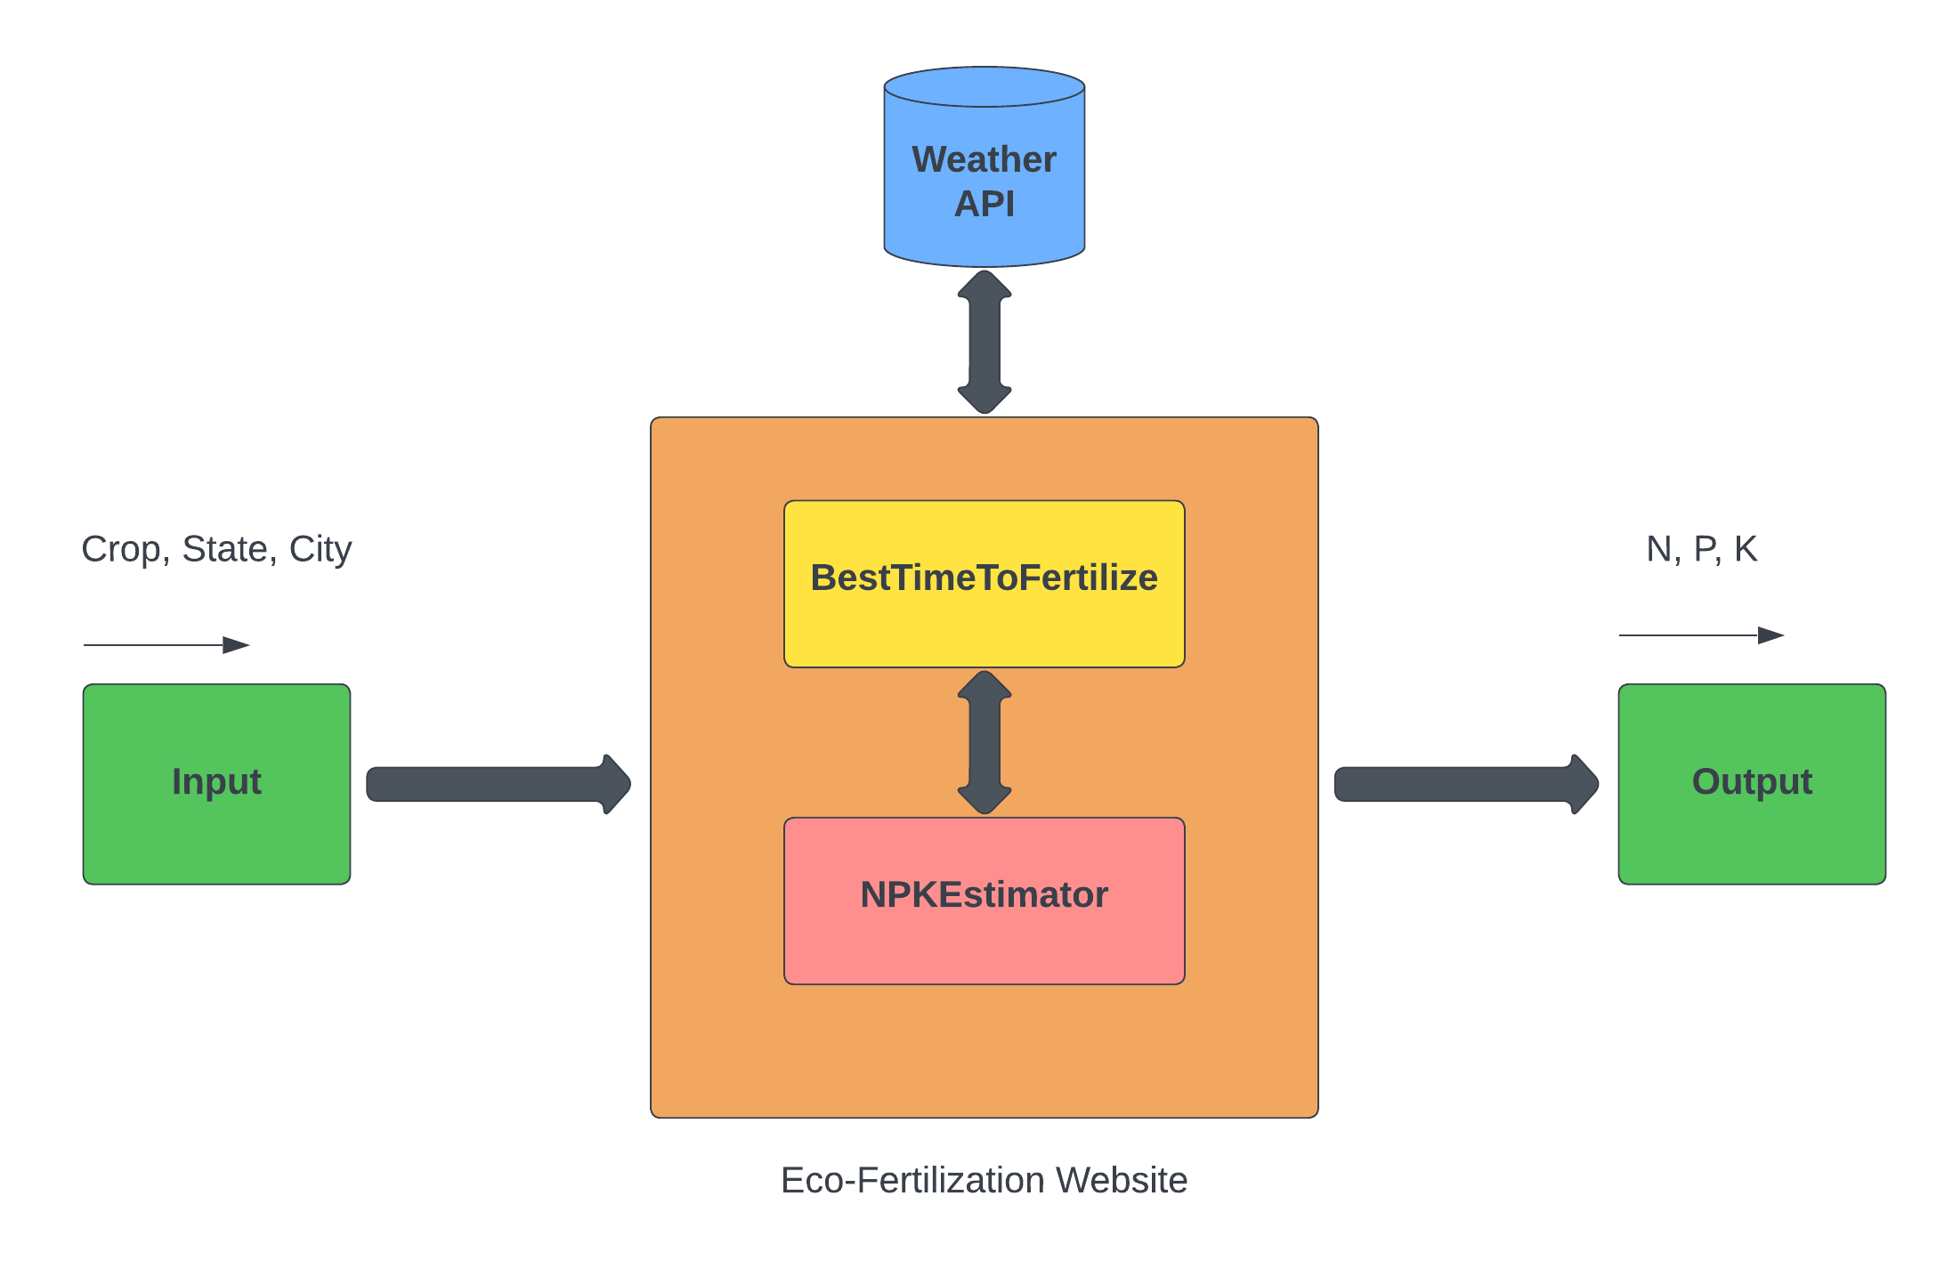

Fig 4.1: Block Diagram

The description of each component from the block diagram above and their major functionalities with respect to the Eco-Fertilization as a complete unit is described in the table below.

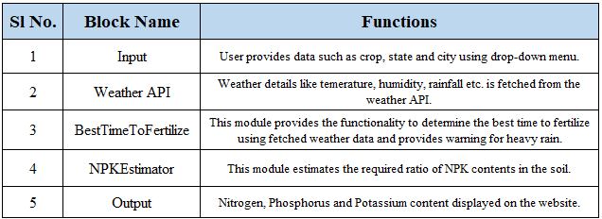

Table 4.1: Block Diagram functionalities

## Data Flow Diagram

A data flow diagram is a graphical representation of the "flow" of data through an information system, modelling its process aspects. It is often used as a preliminary step to create an overview of the system without going into great detail, which can later be elaborated. They can also be used for the visualization of data processing.

A Data Flow Diagram shows what kind of information will be input to and output from the system, how the data will advance through the system, and where the data will be stored. It does not show information about the timing of process or information about whether processes will operate in sequence or in parallel unlike a flowchart which also shows this information.

As shown in Fig 4.2, the system requires input from the user (such as location and crop). The location is fed to the Weather API which will return certain characteristics (e.g. temperature, humidity, rainfall) and if there is a possibility of heavy rainfall, a precautionary message is displayed to the user, otherwise, the proposed algorithm is followed.

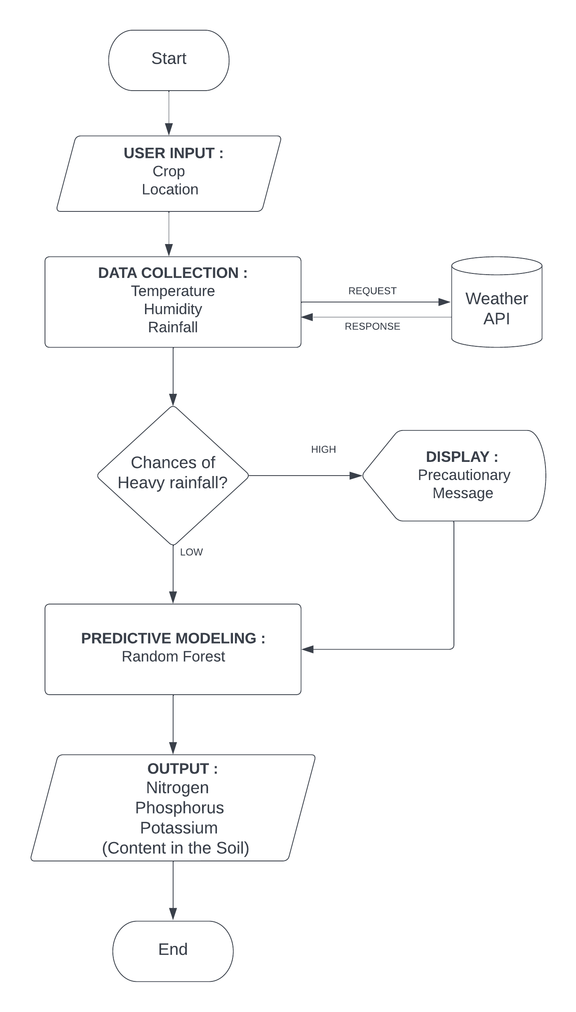

Fig 4.2: Data flow Diagram

## Class Diagram

Class diagram is a static diagram. It represents the static view of an application. Class diagram is not only used for visualizing, describing, and documenting different aspects of a system but also for constructing executable code of the software application.

Class diagram shows a collection of classes, interfaces, associations, collaborations, and constraints. It is also known as a structural diagram.

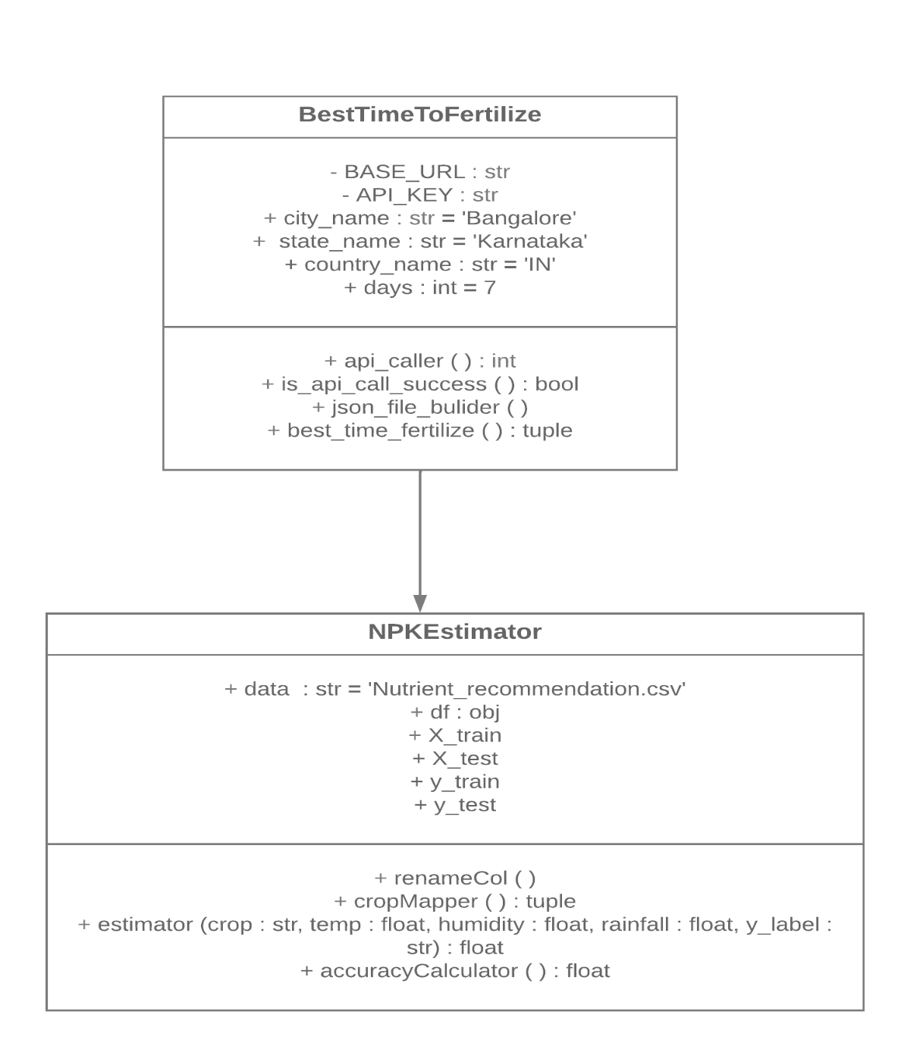

Fig 4.3: Class Diagram

## Sequence Diagram

A sequence diagram shows object interactions arranged in time sequence. It depicts the objects and classes involved in the scenario and the sequence of messages exchanged between the objects needed to carry out the functionality of the scenario. Sequence diagrams are typically associated with use case realizations in the Logical View of the system under development. Sequence diagrams are sometimes called event diagrams or event scenarios.

A sequence diagram consists of parallel vertical lines (lifelines) which shows different processes or objects that live simultaneously, and horizontal arrows that depicts the messages exchanged between them, in the order in which they occur. This allows the specification of simple runtime scenarios in a graphical manner.

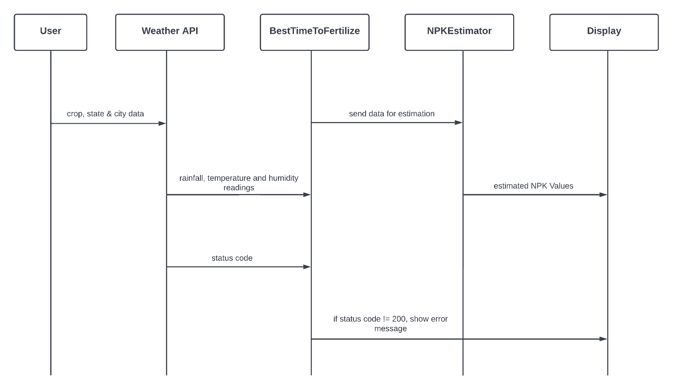

Fig 4.3: Sequence Diagram

**CHAPTER V**

# IMPLEMENTATION

System Implementation uses the structure created during architectural design and the results of system analysis to construct system elements that meet the stakeholder requirements and system requirements developed in the early life cycle phases. These system elements are then integrated to form intermediate aggregates and finally the complete system-of-interest (SoI). Implementation is the process that actually yields the lowest-level system elements in the system hierarchy (system breakdown structure). System elements are made, bought, or reused. Production involves the hardware fabrication processes of forming, removing, joining, and finishing, the software realization processes of coding and testing, or the operational procedures development processes for operators' roles.

Modular design, or "modularity in design", is a design approach that subdivides a system into smaller parts called modules or skids, that can be independently created and then used in different systems. A modular system can be characterized by functional partitioning into discrete scalable, reusable modules; rigorous use of well-defined modular interfaces; and making use of industry standards for interfaces.

## Random Forest Regression

Random forest (RF) is a collection of multiple decision trees that have variable hyper-parameters and are trained using varying subsets of data. In our project, we are going to take crop and location as input, and based on it, we will predict the value of N, P, and K. First, we will divide our dataset into training and test datasets, where the training dataset is 80% of the original data and the rest 20% is test data. Then we will create three different random forests of size 50 (decision tree) for each N, P, and K and outputs the mean of the classes as the prediction of all the trees, shown in Table 5.1.

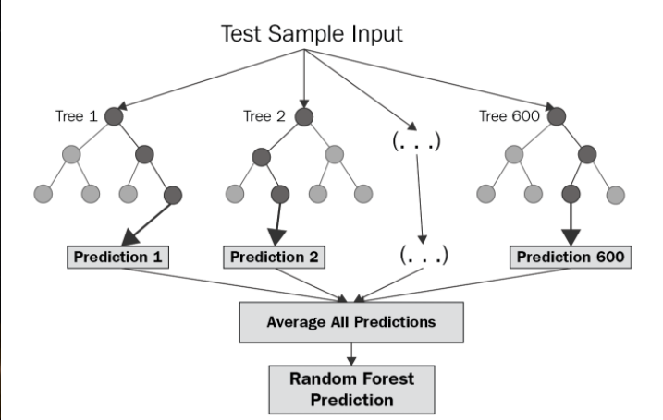Fig.5.1: Random Forest Regression

|  |
| --- |
| **BEGIN:** |
| **Step 1**: The dataset of size n = 2200 is divided into training and test dataset (where the raining set is 80% and the test set is 20% that is training set=1,760 and the test set=240). |
| **Step 2**: Apply random forest regression to each N, P and K (Nitrogen, Phosphorus & Potassium) value with n estimators=50 (n estimators is the number of decision trees). |
| **Step 3**: Train the N Label, P Label and K Label with the training dataset and dependent variable (Where the dependent variable is N for N Label, P for  P Label and K for K Label). |
| **Step 4**: Each N Label, P Label and K Label generates a 50 decision tree as an output based on the training dataset. |
| **END** |

Table 5.1: Random Forest Regression Algorithm

## Cross-Validation

Cross-validation is a resampling technique for testing machine learning models on a small set of data. The algorithm has only one parameter, k, which determines how many groups a given data sample should be divided into. As a result, k-fold cross-validation is a common name for the procedure. When a specific number for k is supplied, it can be used in place of k in the model's reference, such as k=4 for 4-fold cross-validation.

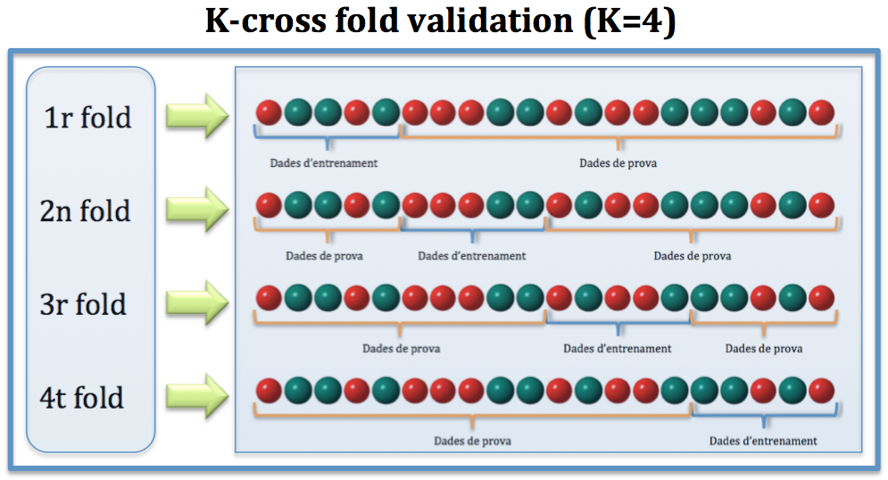

Fig.5.2: K-Cross Fold Validation

## Dataset

Dataset used in our proposed system:

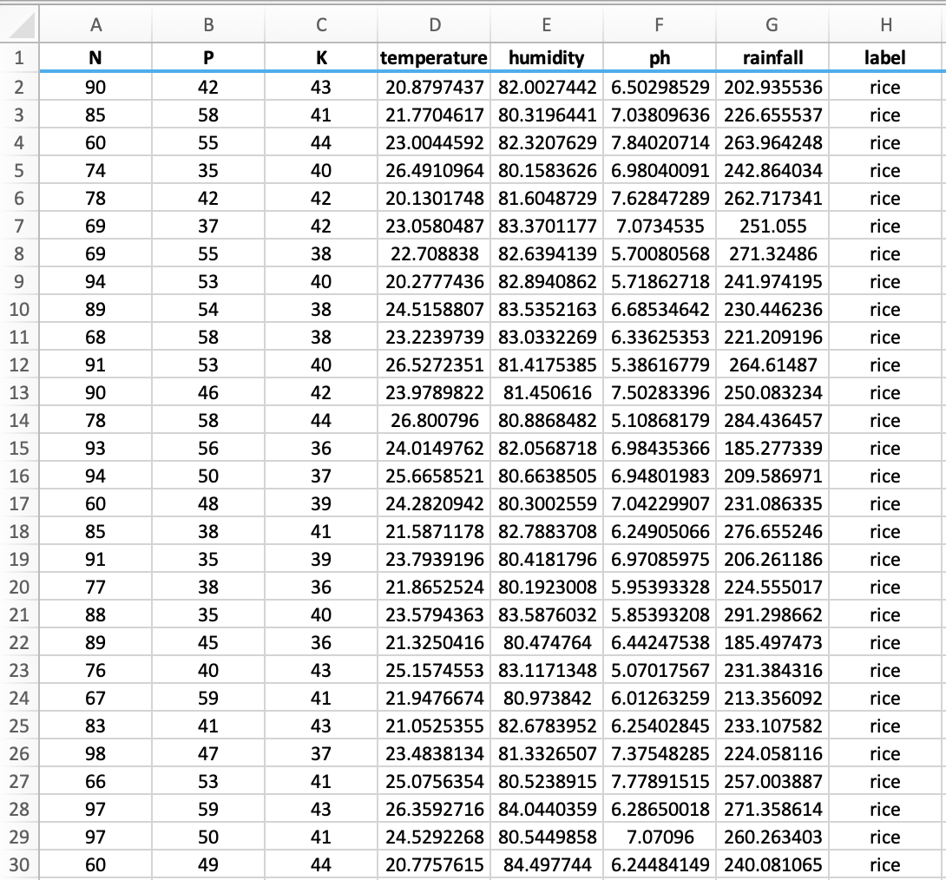

Fig.5.3: Actual Dataset

Crop Recommendation Dataset [20]

Last access date: 16.11.2021

## Data Preparation

Actual dataset contains eight features. All of the features are not useful for the proposed model. Therefore, a dimension reduction technique called feature selection is applied and seven features, then selected for evaluation.

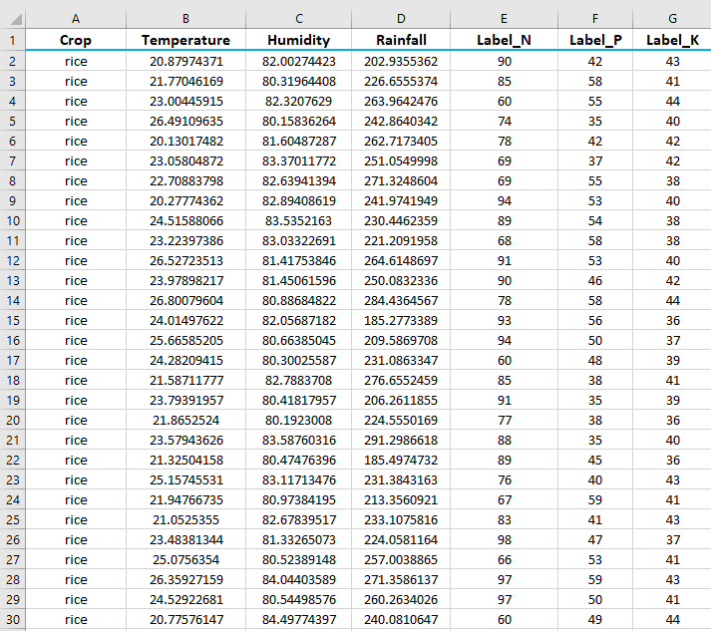Fig 5.4: Customized Dataset

## Input Features

Below are the input features of our system:

* **Crop:** rice, cotton, mango, orange, lentil, etc.
* **Temperature:** temperature measured in Celsius
* **Humidity:** measured relatively in percentages
* **Rainfall:** rainfall in mm

## Output Features

Below are the output features of our system:

* **Label_N:** ratio of Nitrogen content in soil
* **Label_P:** ratio of Phosphorus content in soil
* **Label_K:** ratio of Potassium content in soil

## Python

Python is a general-purpose, high-level, interpreted programming language. It supports a variety of programming paradigms, including structured (especially procedural) programming, object-oriented programming, and functional programming. Python can be used as a scripting language for web applications, such as via Apache's mod wsgi. A consistent API for these applications has emerged in the form of the Web Server Gateway Interface. Django, Pylons, Pyramid, TurboGears, web2py, Tornado, Flask, Bottle, and Zope are web frameworks that let developers design and maintain complex applications. The client-side of Ajax-based apps can be developed with Pyjs and IronPython. SQLAlchemy can be used as a relational database data mapper. Twisted is a framework for programming computer-to-computer communication.

NumPy, SciPy, and Matplotlib, as well as specialized libraries like Biopython and Astropy, make Python an excellent choice for scientific computing. SageMath is a notebook-based Python-programmable computer algebra system that covers a wide range of mathematical disciplines including algebra, combinatorics, numerical mathematics, number theory, and calculus. TensorFlow, Keras, Pytorch, and Scikit-learn are some of the libraries commonly used in Python-based AI and machine learning applications.

Fig 5.7: Python logo

## Flask

flaskFlask is a Python-based micro-web framework. It's referred to as a microframework because it doesn't require any specific tools or libraries. It lacks a database abstraction layer, form validation, or any other components that rely on pre-existing third-party libraries to perform common tasks. Extensions, on the other hand, can be used to add application functionality as if they were built in Flask itself. Object-relational mappers, form validation, upload handling, several open authentication protocols, and a number of standard framework-related tools all have extensions.

Fig 5.8: Flask logo

## HTML

* HTML stands for Hyper Text Markup Language.
* HTML is used for developing web-pages & applications.
* Hyper Text: HyperText is "Text within Text." A text has a link within it, which is a hypertext. Whenever you click on a link it redirects you to a new page, this means you have clicked on a hypertext. Hyper Text can link two or more web pages with each other.
* Markup language: It is a computer language used to apply design and formatting Conferences to a text document. It has the capability to turn text into images, tables etc.
* Web Page: A web page is usually a document written in HTML and translated by a web browser. The web page can be accessed by entering the URL. The web page can be static/dynamic type.
* HTML can be used to create Static Pages.
* HMTL main tags:
  + <!DOCTYPE>: It defines the document type or tells the browser about the version of the HTML.
  + <html>: This tag tells the browser that it is an HTML document.
  + <head>: It should be the first element inside the <html> element, which contains the metadata (information about the document). It must be closed before the body tag opens.
  + <title>: As its name suggests, it is used to add the title of the HTML page that appears at the top of the browser window.
  + <body>: This contains the main content of the HTML.
  + <h1>: Text between <h1> tag describes the first level heading of the webpage.
* Important features of HTML:
  + It is a very simple language. HTML can be understood & modified.
  + It is easy to make an effective presentation with HTML.
  + It provides a flexible way to design web pages with text.
  + It enables programmers to add a link to web pages (via the html anchor tag), thus increasing the user's browsing interest.
  + It is platform-independent because it can be displayed on any platform such as Windows, Linux and Macintosh.
  + It facilitates the programmer to add graphics, videos and sound to web pages that make it more attractive and interactive.
  + HTML can use tags in both lower-case and upper-case.

Fig 5.9: HTML logo

## CSS

* CSS means cascading style sheets.
* It is a language which describes the representation of web pages, including colors, layout and fonts, making web pages more user-friendly.
* The main function of CSS is to make style sheets for the web. It is even independent of HTML.
* Let’s dissect the acronym:
  + Cascading: Falling of Styles
  + Style: Adding Styling to our HTML tags
  + Sheets: Writing style in different documents.
* There are 3 ways to write CSS in our HTML file:
  + Inline CSS
  + Internal CSS
  + External CSS
* Considering Priority:
  + Inline > Internal > External
* Inline CSS:
  + The only way to apply a style.
  + Independence
  + Clearly applies to each element.
  + The idea of ​​separation of concerns has been lost.
* Internal CSS:
  + We can use style tags to apply styles in HTML files.
  + Redundancy is removed.
  + But the idea of ​​separation of concerns is still lost.
  + Uniquely applied to a single document
* External CSS:
  + With the help of <link> tag in the head tag, we can apply styles.
  + References are added.
  + Files saved with a .css extension.
  + Redundancy is removed.
  + The idea of ​​separation of concerns is retained.
  + Uniquely applied to each document

Fig 5.10: CSS logo

## Parallax Effect

* The parallax effect is one of the little tricks that can make our landing page great and get our visitors' attention.
* CSS has matured considerably in the last few years. In short, there is a lot of flexibility in how things are done.
* The parallax effect is when two slices moving at a constant speed move at a constant speed.
* We have seen a parallax effect app in front of a 2D game. In those apps, the background changes slowly compared to the front.
* We have noticed the parallax effect when the object is sitting in a car that is moving slower than other cars on the road.
* Simply put, the conditions that must be met for a parallax effect to occur are:
  + The parallax layer's perception changes, so it appears to move relatively fast or slowly without deviating from its original size.
  + Do not change the position or speed.
* To achieve both of these conditions, you need to increase the perceived distance between the user and the plane before moving along the negative Z axis.
* The longer the apparent distance, the smaller the aircraft may look. To counter this size reduction, you can reduce it to its original size.
* This mainly means using two CSS properties, Perspective and Transform. Use translateZ () and scale () transformation.

## JavaScript

* JavaScript is a scripting language for websites.
* Known for developing websites that are also used in many non-browser environments.
* JavaScript is both an imperative language and a declarative language. JavaScript contains a standard library of objects such as arrays, dates, math, etc.
* Client-side: Provides objects to control the browser and its Document Object Model (DOM).
* For example, client-side extensions allow your application to place elements in HTML. • Respond to forms and user events such as mouse clicks, form submissions, page navigation, etc.
* Convenient client-side libraries include AngularJS, ReactJS, and VueJS.
* Server-side: Provides objects related to the execution of JavaScript on the server.
* Imperative Languages-In this type of language, we are primarily interested in how to do it.
* Controls only the calculation flow. The object-oriented approach, which is a procedural programming approach, is equivalent to asynchronous wait when considering what to do next after an asynchronous call.
* Declarative programming: I'm worried about how to do that in this kind of language. Basically, it requires logical operations. The main goal here is to explain the desired result without directly defining the acquisition method like the arrow function.
* JavaScript can be added to HTML in two ways:
  + Internal JS: Tags can be placed within one or more tags as needed.
  + External JS: You can write the JavaScript code in another file with a .js extension and link that file inside the tag of the HTML file to which you want to add this code.



Fig 5.12: JavaScript logo

**CHAPTER VI**

# SOFTWARE DESCRIPTION

This chapter describes about the software used in this project to meet our needs. The software description is as explained below:

## VS CODE

Visual Studio Code is a Microsoft-specific adaptation of the Code - OSS repository provided under a typical Microsoft product license. Visual Studio Code blends the ease of use of a code editor with the features that developers require to complete their edit-build-debug cycle. It includes lightweight debugging, a deep extension architecture, and a lightweight interface with existing tools, as well as extensive code editing, navigation, and understanding assistance. New features and bug fixes are added to Visual Studio Code monthly. Visual Studio Code is available for download on the Visual Studio Code website for Windows, macOS, and Linux.

Fig.6.1: VS Code logo

## GIT

Git is a distributed version control system that is free and open-source, and it can handle projects of any size, from small to large. Git is simple to understand and use, has a minimal footprint, and performs well. With capabilities like low-cost local branching, convenient staging regions, and multiple processes, it outperforms SCM solutions like Subversion, CVS, Perforce, and ClearCase. Git fosters and supports the creation of a large number of self-contained local branches. In a matter of seconds, such development lines can be established, merged, and erased.

Fig.6.2: Git logo

## JUPYTER NOTEBOOK

Jupyter Notebook is an open source web tool for creating and sharing documents with live code, equations, visualizations, and text. Project Jupyter is in charge of maintaining Jupyter Notebook. Jupyter Notebooks is a fork of the IPython project, which used to have its own IPython Notebook project. Jupyter gets its name from the three main programming languages it supports: Julia, Python, and R. Jupyter comes with the IPython kernel, which allows you to develop Python programmers, but there are over 100 different kernels available right now.

Fig.6.3: Jupyter Notebook logo

**CHAPTER VII**

# RESULTS

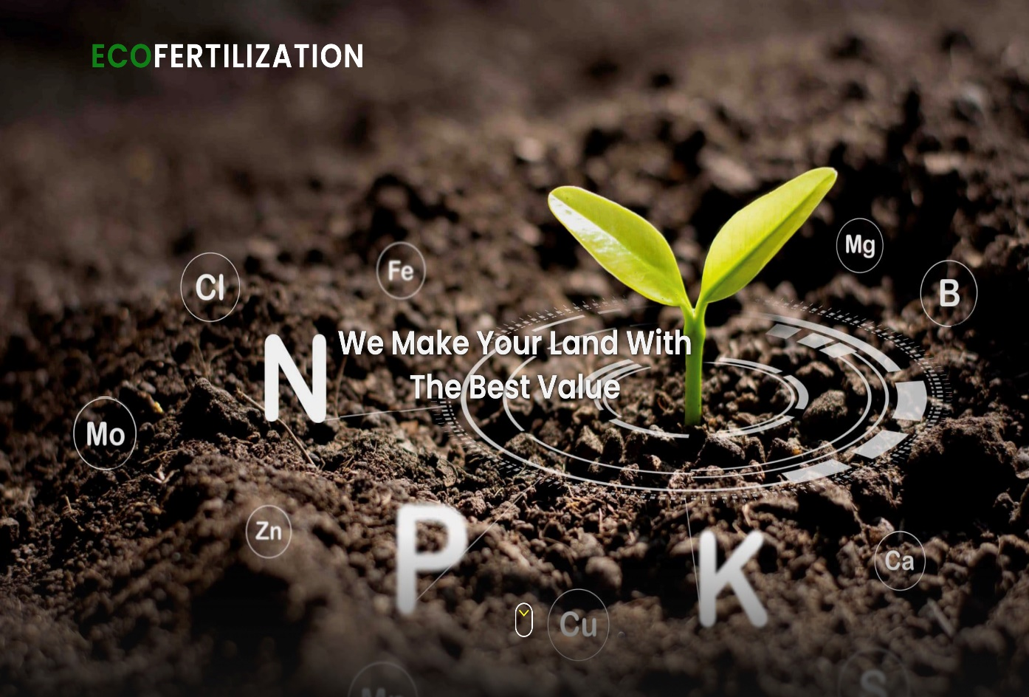Eco-Fertilization, a user-friendly system, has been implemented in the form of a website to provide cross-platform functionality and suggest appropriate timings and amount of nutrients required for an inputted crop with alert system for heavy rainfall (as shown in Fig 7.1-7.5).

Fig 7.1: Homepage of Eco-Fertilization

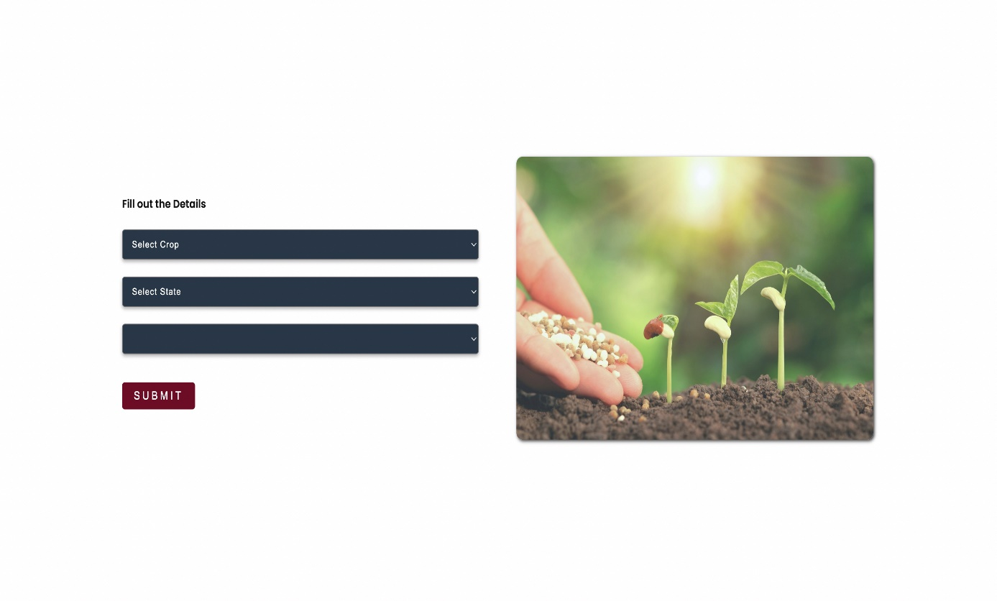

Fig7.2: Input Form

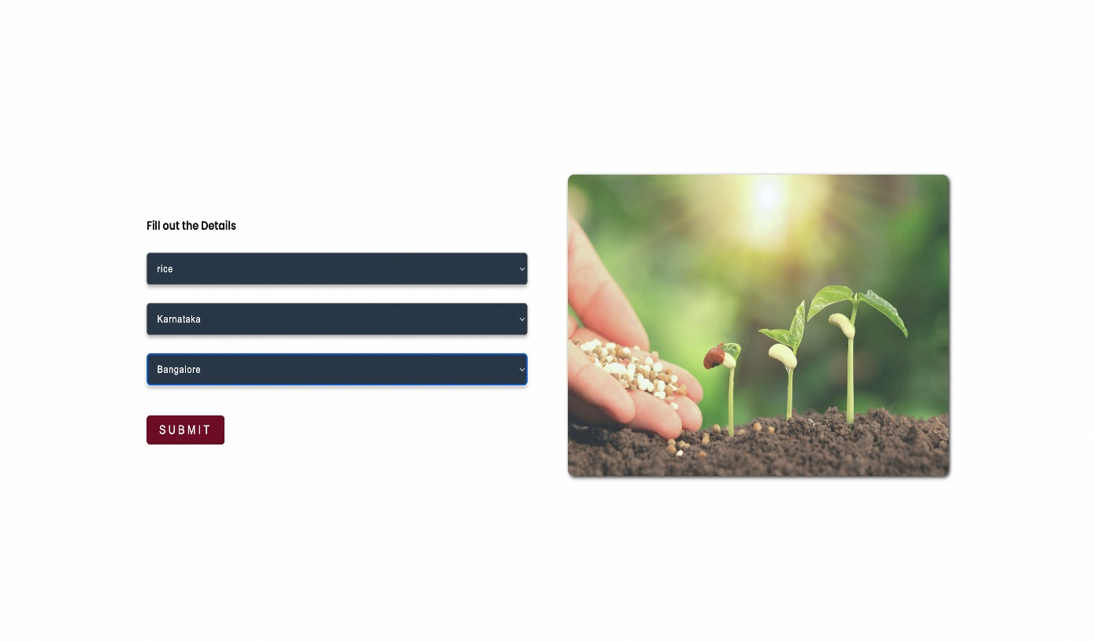

Fig 7.3: Details filled using the drop-down menu

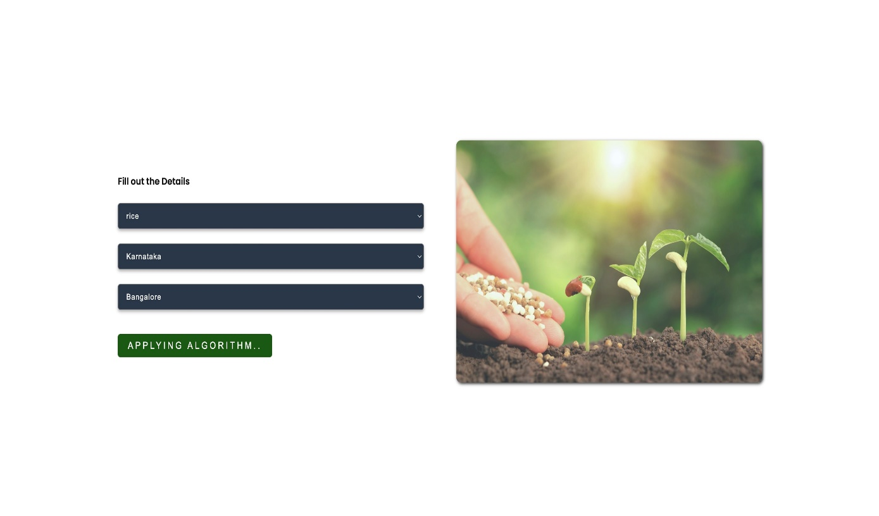

Fig 7.4: Applying Algorithm to inputted details

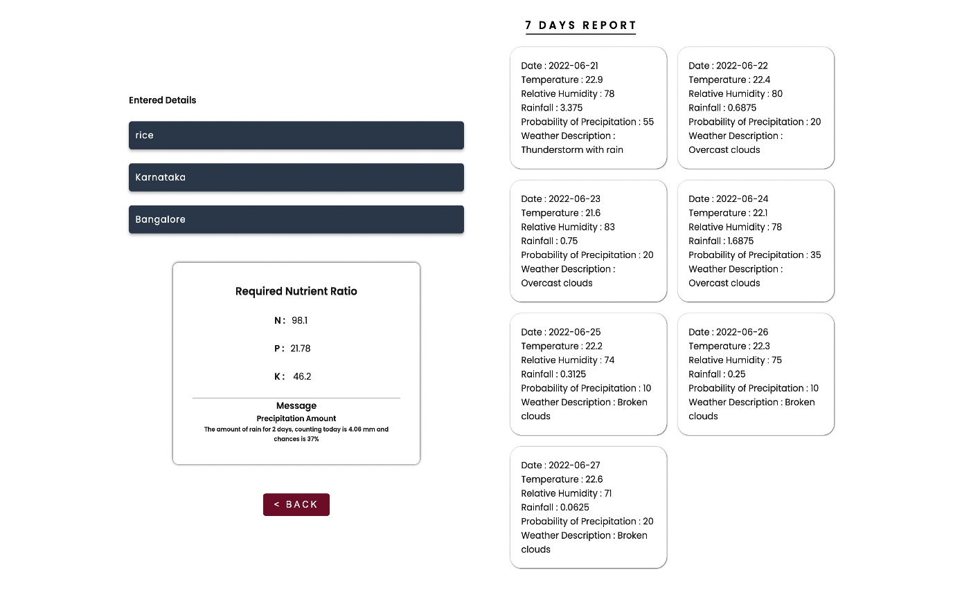

Fig 7.5: Output with seven days of weather forecasts & alerts/messages

**CHAPTER VIII**

# APPLICATIONS AND FUTURE WORKS

## Applications

* This project is useful in the agriculture sector.
* Can be used to reduce the wastage of fertilizers.
* Used to suggest nutrient recommendations for the crops.
* It reduces water pollution by slowing down the process of soil leaching as fertilizers can reach the water table and contaminate shallow groundwater and deep aquifers.
* Reduce leaching and runoff potential.
* It provides weather alerts and messages. Alerts are displayed in the output of this application in case of bad weather conditions.
* Seven-day weather forecasts to timely plan the fertilization.

## Future Scope

The proposed system provides a helping hand to our farmers. It gives information about the use and quantity of nutrients required by the crops. There is scope for improvement in the system by providing user interface in the native language, so that the user can operate the system easily if he or she is unfamiliar with the English language. In addition, speech recognition systems can be added to handle illiterate users.

**CHAPTER IX**

# CONCLUSION

This chapter describes about the conclusion.

**CHAPTER X**

# PAPER PUBLICATION DETAILS

Below are the paper publication details:

**CHAPTER XI**

# REFERENCES

[1] Krutika Hampannavar, Vijay Bhajantri, Shashikumar G. Totad “Prediction of Crop Fertilizer Consumption,” Fourth International Conference on Computing Communication Control and Automation (ICCUBEA),2018, PP.1-5

[2] G. Prabakaran, D. Vaithiyanathan, Madhavi Ganesa, “Fuzzy decision support system for improving the crop productivity and efficient use of fertilizers,” Computers and Electronics in Agriculture, vol-150, 2018, PP. 88-97

[3] Shital Bhojani, Nirav Bhatt, “Data Mining Techniques for Crop Yield Prediction,” Computers and Electronics in Agriculture, vol-6, 2018, PP. 357-358

[4] Yulong Yin, Hao Ying, Huifang Zhen, Q ingsong Zhang, Y anfang Xue, Zhenling I, “Estimation of NPK requirements for rice production in diverse Chinese environments under optimal fertilization rate,” Agricultural and Forest Meteorology, vol-279, 2019, PP. 1-6

[5] Laura J.T. Hess, Eve-Lyn S. Hinckley, G. Philip Robertson, Pamela A. Matson, “Rainfall intensification increases nitrate leaching from tilled but not no-till cropping systems in the U.S. Midwest,” Agriculture, Ecosystems & Environment, vol-290, 2020, PP. 1-10

[6] Potnuru Sai Nishant,Pinapa Sai Venkat,Bollu Lakshmi Avinash,B. Jabber, “Crop Yield Prediction Based on Indian Agriculture using Machine Learning,” 2020 International Conference for Emerging Technology (INCET), 2020, PP. 1-4

[7] Tony Yang, Kadambot H.M., Siddique, Kui Liu, “Cropping systems in agriculture and their impact on soil health,” Global Ecology and Conservation, vol-23, year, PP. 1-13

[8] János Kátai, Ágnes Oláh Zsuposné, Magdolna Tállai, Tarek Alshaal, “Would fertilization history render the soil microbial communities and their activities more resistant to rainfall fluctuations? ,” Ecotoxicology and Environmental Safety, vol-201, 2020, PP. 1-11

[9] Usman Ahmed, Jerry Chun-Wei Lin, Gautam Srivastava, Youcef Djenouri, “A nutrient recommendation system for soil fertilization based on Evolutionary Computation,” Computers and Electronics in Agriculture, vol-189, 2021, PP. 1-7

[10] A.Hussein, Diogenes L. Antille, Shreevatsa Kodur, GuangnanChen, Jeff N.Tullberg, “Controlled traffic farming effects on productivity of grain sorghum, rainfall and fertilizer nitrogen use efficiency,” Journal of Agriculture and Food Research, vol-3, 2021, PP. 1-17

[11] Zujiao Shi, Donghua Liu, Miao Liu, Muhammad Bilal Hafeez, Pengfei Wen, Xiaoli Wang, Rui Wang, Xudong Zhang, Jun Li, “Optimized fertilizer recommendation method for nitrate residue control in a wheat–maize double cropping system in dryland farming,” Field Crops Research, vol-271, 2021, PP. 1-10

[12] Janmejay Pant, R.P. Pant, Manoj Kumar Singh, Devesh Pratap Singh, Himanshu Pant, “Analysis of agricultural crop yield prediction using statistical techniques of machine learning,” Materials Today: Proceedings, vol-46, 2021, PP. 1-10

[13] Benny Antony, “Prediction of the production of crops with respect to rainfall.,” Environmental Research, vol-202, 2021, PP. 1-5

[14] Akash Manish Lad, K. Mani Bharathi, B. Akash Saravanan, R. Karthik, “Factors affecting agriculture and estimation of crop yield using supervised learning algorithms,” Materials Today: Proceedings, 2022, PP. 1-10

[15] Raves Akhtar, Shabbir Ahmad Sofi, “Precision agriculture using IoT data analytics and machine learning,” Journal of King Saud University - Computer and Information Sciences, 2021, PP. 1-17

[16] Saheed Garnaik, Prasanna Kumar Samant, Mitali Mandal, Tushar Ranjan Mohanty, Sanat Kumar Dwibedi, Ranjan Kumar Patra, Kiran Kumar Mohapatra, R.H. Wanjari, Debadatta Sethi, Dipaka Ranjan Sena, Tek Bahadur Sapkota, Jagmohan Nayak, Sridhar Patra, Chiter Mal Parihar, Hari Sankar Nayak, “Untangling the effect of soil quality on rice productivity under a 16-years long-term fertilizer experiment using conditional random forest,” Computers and Electronics in Agriculture, vol-197,2022, PP. 1-10

[17] Rubby Aworka, Lontsi Saadio Cedric, Wilfried Yves Hamilton Adoni, Jérémie Thouakesseh Zoueu, Franck Kalala Mutombo, Charles Lebon Mberi Kimpolo, Tarik Nahhal, Moez Krichen, “Agricultural decision system based on advanced machine learning models for yield prediction: Case of East African countries,” Smart Agricultural Technology, vol-3, 2022, PP. 1-9

[18] Senthil Kumar Swami Durai, Mary Divya Shamili, “Smart farming using Machine Learning and Deep Learning techniques,” Decision Analytics Journal, vol-2, 2022, PP. 1-30

[19] M.S. Suchithra, Maya L. Pai, “Improving the prediction accuracy of soil nutrient classification by optimizing extreme learning machine parameters,” Information Processing in Agriculture, vol-7, 2022, PP. 1-11

[20] Kaggle, “ https://www.kaggle.com/datasets/atharvaingle/crop-recommendation-dataset ” (accessed on 16th November 2021)